Hotel Operation and Service Management System
(HSRM)
Software Design Specification (SDS)

– DaNang, May 2026 –

Record of Changes
Version | Date | Description of Change | Author
v0.1 | May 10, 2026 | Initial structural templates, database migrations setup | Group 2
v1.0 | July 11, 2026 | Integrated room booking, PayOS payments, room lock | Luong Duc Tin
v1.1 | July 12, 2026 | Integrated incident billing, receptionist dashboard, housekeeping status flows | Nguyen Ngoc Tay
v1.2 | July 13, 2026 | Added experience automated SMTP transits, unified staff quick-access redirects | Group 2

I. Overview

1. Code Packages
The Hotel Operation and Service Management System (HSRM) project codebase is structured around a Next.js framework for server-side page routing and interactive layouts, complemented by a PayOS integration backend helper. This package layout facilitates developer modularity, API encapsulation, and database schema integrity. Below is the package architecture description:
Package Path | Scope | Description
project/src/app | Next.js Router & API Route | Coordinates frontend views (client listings, check-in desks, check-out flows, order menus) and Next.js backend serverless APIs.
project/src/components | Reusable UI Components | Contains custom cards, input elements, tables, and modal elements for incidents, bookings, and cleaning flows.
project/src/lib | Authentication & Database | Houses local context providers, authentication hooks, nodemailer configurations, and Supabase client libraries.
project/backend-payos | VietQR Express Payment Server | Verifies dynamic VietQR PayOS payments, triggers automated experience tour emails, and logs loyalty point awards.
project/supabase/migrations | SQL DDL Schemas | Stores migration scripts ensuring tables, checks, indexes, and triggers align with functional specifications.

2. Database Design

a. Database Schema
The HSRM database design employs PostgreSQL as its core engine. Primary and foreign keys strictly utilize UUID data formats to ensure scalability and cross-system consistency. The database schema links the customer accounts (users), their booking transactions (bookings, guests, payments), room assets (rooms, room_types, room_locks), and back-office incident and service tracking tables (room_incidents, service_orders) in a highly relational structure.

b. Table Description

Table: users
Column Name | Data Type | Constraints | Description
id | UUID | PRIMARY KEY, DEFAULT gen_random_uuid() | Unique identifier for user
email | VARCHAR(255) | UNIQUE, NOT NULL | Email address used for logging in
password_hash | VARCHAR(255) | NOT NULL | Bcrypt password hash
full_name | VARCHAR(255) | NOT NULL | User's full name
phone | VARCHAR(20) | NULL | User's contact phone number
role | user_role | DEFAULT 'CUSTOMER' NOT NULL | User role: ADMIN, RECEPTIONIST, HOUSEKEEPING, KITCHEN, CUSTOMER
loyalty_points | INT | DEFAULT 0, CHECK >= 0 | Points earned from bookings
is_active | BOOLEAN | DEFAULT true NOT NULL | Account status
created_at | TIMESTAMPTZ | DEFAULT now() NOT NULL | Record creation timestamp

Table: rooms
Column Name | Data Type | Constraints | Description
id | UUID | PRIMARY KEY, DEFAULT gen_random_uuid() | Unique identifier for room
room_number | VARCHAR(10) | UNIQUE, NOT NULL | Individual room label
floor | INT | DEFAULT 1 NOT NULL | Floor level of the room
room_type_id | UUID | REFERENCES room_types(id) NOT NULL | Link to room type configuration
status | room_status | DEFAULT 'AVAILABLE' NOT NULL | Live status: AVAILABLE, IN_USE, DIRTY, CLEANING, MAINTENANCE
status_updated_at | TIMESTAMPTZ | DEFAULT now() NOT NULL | Last room status modification date
created_at | TIMESTAMPTZ | DEFAULT now() NOT NULL | Record creation timestamp

Table: bookings
Column Name | Data Type | Constraints | Description
id | UUID | PRIMARY KEY, DEFAULT gen_random_uuid() | Unique booking reservation reference
user_id | UUID | REFERENCES users(id) NOT NULL | Link to the customer account
room_id | UUID | REFERENCES rooms(id) NOT NULL | Link to the assigned room
guest_id | UUID | REFERENCES guests(id) | Link to checked-in guest details
status | booking_status | DEFAULT 'PENDING' NOT NULL | Reservation status: PENDING, CONFIRMED, CHECKED_IN, CHECKED_OUT, CANCELLED
total_amount | DECIMAL(12,2) | DEFAULT 0 NOT NULL | Total amount charged for stay
special_requests | TEXT | NULL | Special requests or experience metadata JSON
created_at | TIMESTAMPTZ | DEFAULT now() NOT NULL | Record creation timestamp

Table: room_locks
Column Name | Data Type | Constraints | Description
id | UUID | PRIMARY KEY, DEFAULT gen_random_uuid() | Lock entry identifier
room_id | UUID | UNIQUE, REFERENCES rooms(id) ON DELETE CASCADE | The locked room
user_id | UUID | REFERENCES users(id) ON DELETE CASCADE | The lock owner
locked_until | TIMESTAMPTZ | NOT NULL | Lock expiration timestamp (typically 10 minutes)
created_at | TIMESTAMPTZ | DEFAULT now() NOT NULL | Lock creation timestamp

Table: room_incidents
Column Name | Data Type | Constraints | Description
id | UUID | PRIMARY KEY, DEFAULT gen_random_uuid() | Incident record reference
incident_code | VARCHAR(50) | UNIQUE, NOT NULL | Human-readable incident code
booking_id | UUID | REFERENCES bookings(id) | Associated booking reservation
room_id | UUID | REFERENCES rooms(id) | Room where the incident took place
customer_id | UUID | REFERENCES users(id) | Customer account billed
reported_by_user_id | UUID | REFERENCES users(id) | Staff account that reported the incident
incident_type | VARCHAR(50) | NOT NULL | Type: DAMAGE, MISSING_HOTEL_ITEM, GUEST_LOST_ITEM, FOUND_ITEM, MAINTENANCE, COMPLAINT, OTHER
severity | VARCHAR(20) | NOT NULL | Severity: LOW, MEDIUM, HIGH, CRITICAL
description | TEXT | NOT NULL | General description of damage or incident
estimated_charge | DECIMAL(12,2) | DEFAULT 0 | Estimated repair fine amount
approved_charge | DECIMAL(12,2) | DEFAULT 0 | Approved fine amount to bill
is_chargeable | BOOLEAN | DEFAULT false | True if guest needs to be fined on checkout
status | VARCHAR(50) | NOT NULL | Workflow status: REPORTED, INVESTIGATING, APPROVED, RESOLVED, CLOSED, CANCELLED

Table: lost_found_items
Column Name | Data Type | Constraints | Description
id | UUID | PRIMARY KEY, DEFAULT gen_random_uuid() | Item entry reference
incident_id | UUID | REFERENCES room_incidents(id) ON DELETE SET NULL | Associated incident code
item_code | VARCHAR(50) | UNIQUE, NOT NULL | Unique lost and found code
item_name | VARCHAR(255) | NOT NULL | Name/type of the found object
found_by_user_id | UUID | REFERENCES users(id) | Staff who recovered the item
storage_location | VARCHAR(255) | NULL | Physical shelf storage location
status | VARCHAR(50) | NOT NULL | Status: FOUND, STORED, CLAIMED, RETURNED, CLOSED

II. Code Designs

1. Room Management Module
Coordinates room lists, floor assignments, and cleanliness states. Housekeeping staff can mark rooms as CLEANING, and receptionists can override states in emergencies.

a. Class Diagram
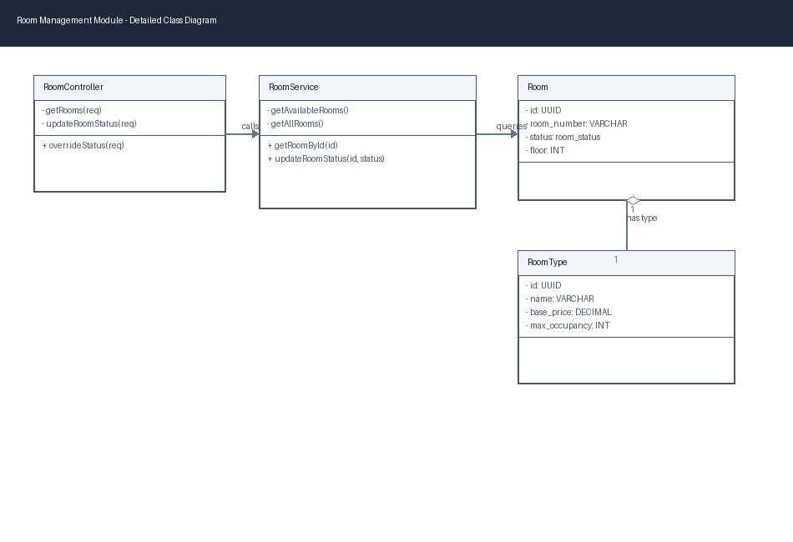

b. Class Specifications
Component / Class | Scope / Type | Responsibilities
RoomController (API Handler) | project/src/app/api/rooms/[id]/status/route.ts | Receives request to update cleanliness or occupancy statuses and logs events.
RoomService (Service Class) | project/src/lib/db/rooms.ts | Interacts with rooms, room_types and room_locks database tables.
Room (Entity Class) | project/src/types/hotel.ts | Contains room properties including id, room_number, status, floor, and timestamps.
RoomType (Entity Class) | project/src/types/hotel.ts | Defines characteristics of room types including name, base_price, capacity, and amenities.

c. Sequence Diagram(s)
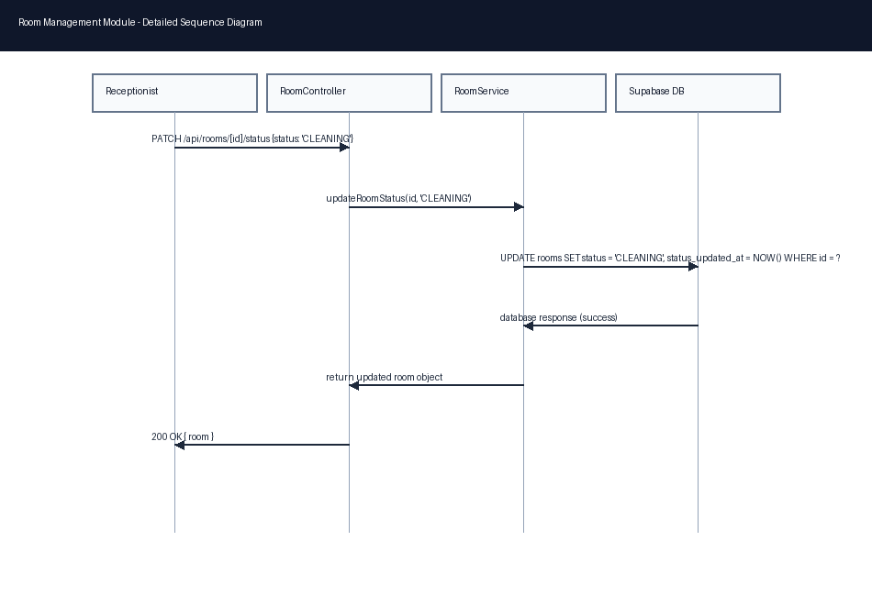

d. Database Queries

Query Room List with Types
SELECT r.id, r.room_number, r.floor, r.status, rt.name FROM rooms r
LEFT JOIN room_types rt ON r.room_type_id = rt.id ORDER BY r.room_number ASC;

Update Cleanliness State
UPDATE rooms SET status = 'AVAILABLE', status_updated_at = NOW() WHERE id = $1;

2. Booking & AI OCR Check-in Module
Manages room stay bookings, secures temporary room locks to prevent overbooking, and integrates AI OCR ID scanning to verify guest credentials during front-desk check-in.

a. Class Diagram
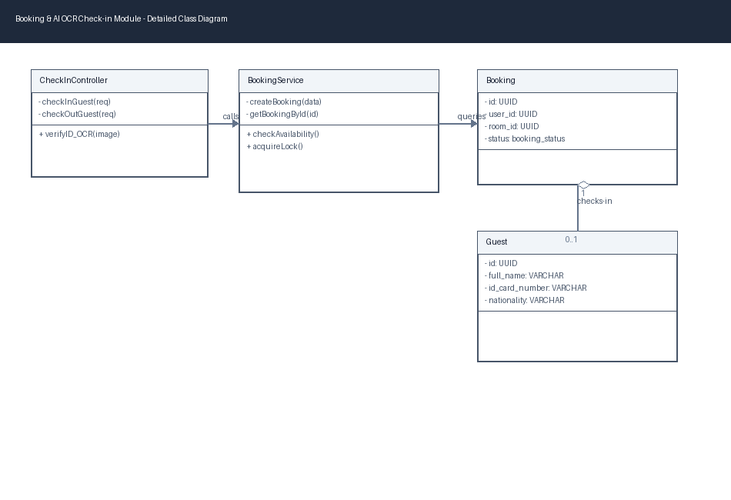

b. Class Specifications
Component / Class | Scope / Type | Responsibilities
CheckInController (API Controller) | project/src/app/api/checkin/route.ts | Exposes POST check-in flow and initiates database guest registration.
BookingService (Service Class) | project/src/lib/db/bookings.ts | Maintains bookings reservation states and enforces dates overlaps checking.
Booking (Entity Class) | project/src/types/hotel.ts | Data structure containing reservation parameters (user_id, room_id, guest_id, check_in_date, total_amount).
Guest (Entity Class) | project/src/types/hotel.ts | Holds guest profiling attributes (full_name, id_card_number, nationality, address).

c. Sequence Diagram(s)
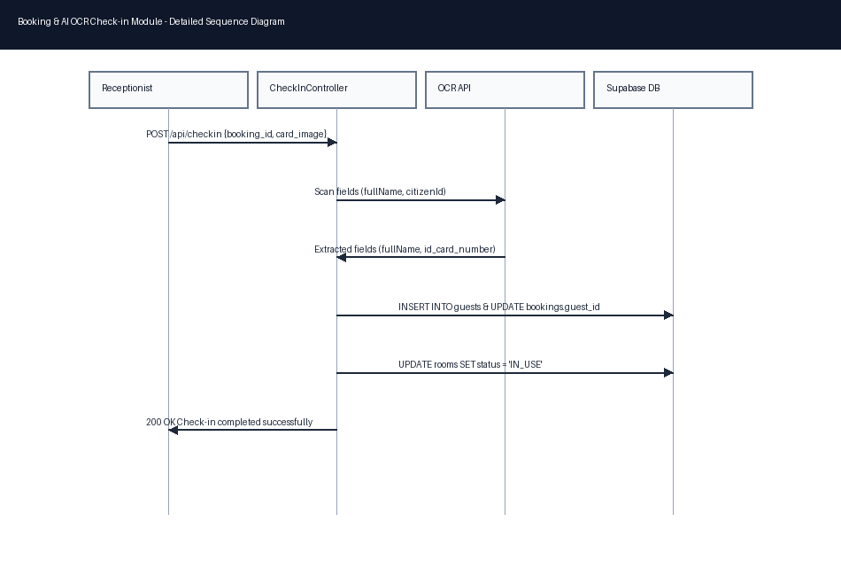

d. Database Queries

Atomic Room Lock Allocation
INSERT INTO room_locks (room_id, user_id, locked_until)
VALUES ($1, $2, NOW() + INTERVAL '10 minutes')
ON CONFLICT (room_id) DO UPDATE SET locked_until = EXCLUDED.locked_until
WHERE room_locks.locked_until < NOW() RETURNING id;

Create Checked-in Guest Record
INSERT INTO guests (full_name, id_card_number, id_card_type, phone, email, nationality, address)
VALUES ($1, $2, $3, $4, $5, $6, $7) ON CONFLICT (id_card_number) DO UPDATE
SET full_name = EXCLUDED.full_name RETURNING id;

3. Guest Management Module
Oversees guest profile registers and links transactions with the automated guest loyalty rewards system to add points (100k VND = 1 point) upon successful checkout.

a. Class Diagram
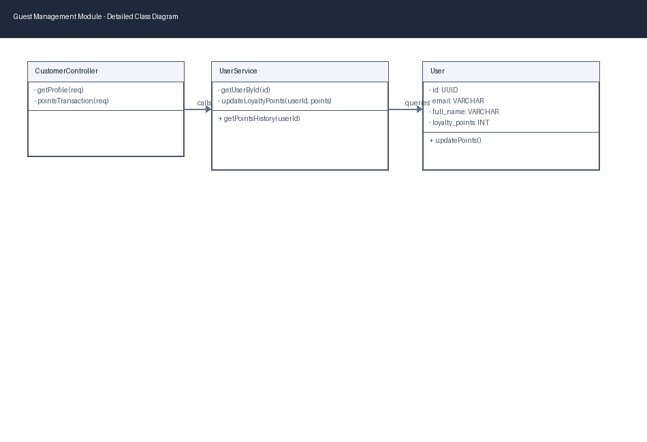

b. Class Specifications
Component / Class | Scope / Type | Responsibilities
CustomerController (API Controller) | project/src/app/api/customers/route.ts | Exposes customer profile fetch API and points transactions history logs.
UserService (Service Class) | project/src/lib/db/users.ts | Handles core customer profile updates and loyalty points additions.
User (Entity Class) | project/src/types/hotel.ts | Represents the user database record holding role, email, password_hash, and loyalty_points.

c. Sequence Diagram(s)
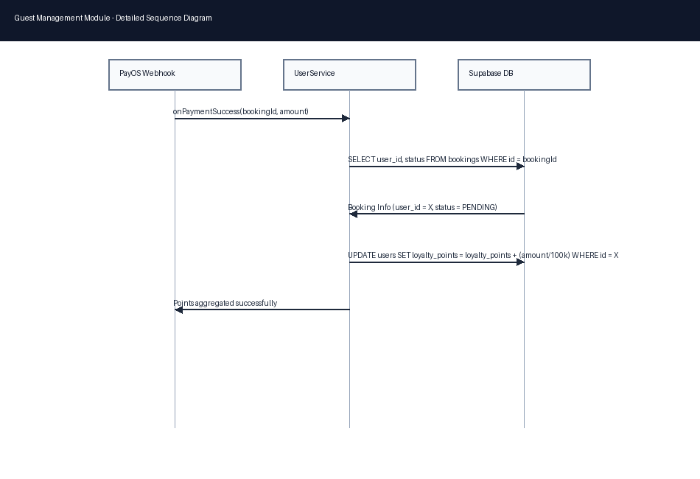

d. Database Queries

Award Loyalty Points to User
UPDATE users SET loyalty_points = loyalty_points + $1 WHERE id = $2;

Select Guest Profile with Points
SELECT id, full_name, email, phone, loyalty_points FROM users WHERE id = $1;

4. Service Ordering & Real-time Synchronization Module
Coordinates ordering of hotel services and food. Connects checkout pages with PayOS to process payments and alerts the kitchen display using WebSockets.

a. Class Diagram
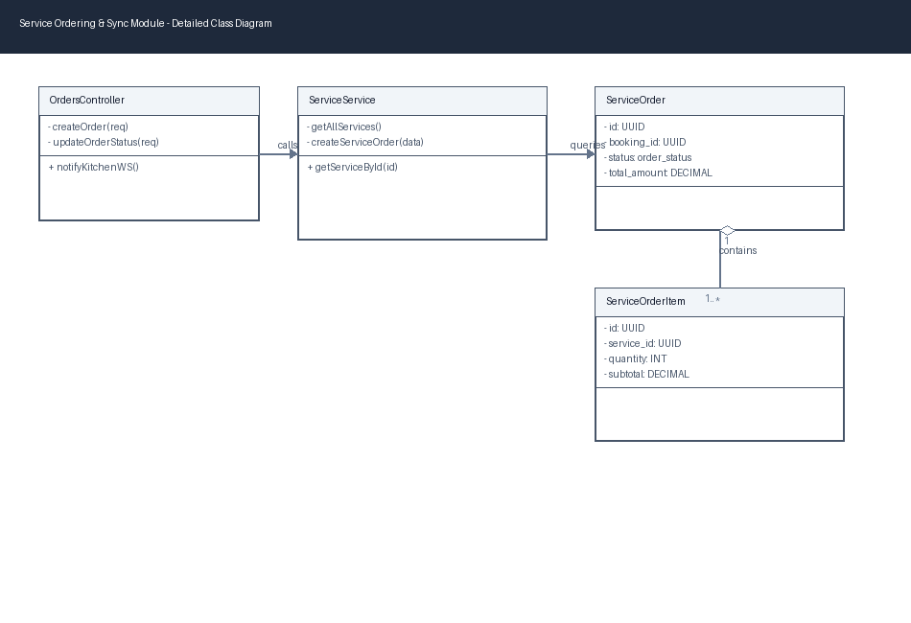

b. Class Specifications
Component / Class | Scope / Type | Responsibilities
OrdersController (API Controller) | project/src/app/api/orders/route.ts | Handles orders creation and updates food/drink status states.
ServiceService (Service Class) | project/src/lib/db/services.ts | Queries food menu items catalog and adds items to order structures.
ServiceOrder (Entity Class) | project/src/types/hotel.ts | Holds order attributes like booking_id, status, total_amount, and notes.
ServiceOrderItem (Entity Class) | project/src/types/hotel.ts | Represents ordered item breakdown storing service_id, quantity, and subtotal.

c. Sequence Diagram(s)
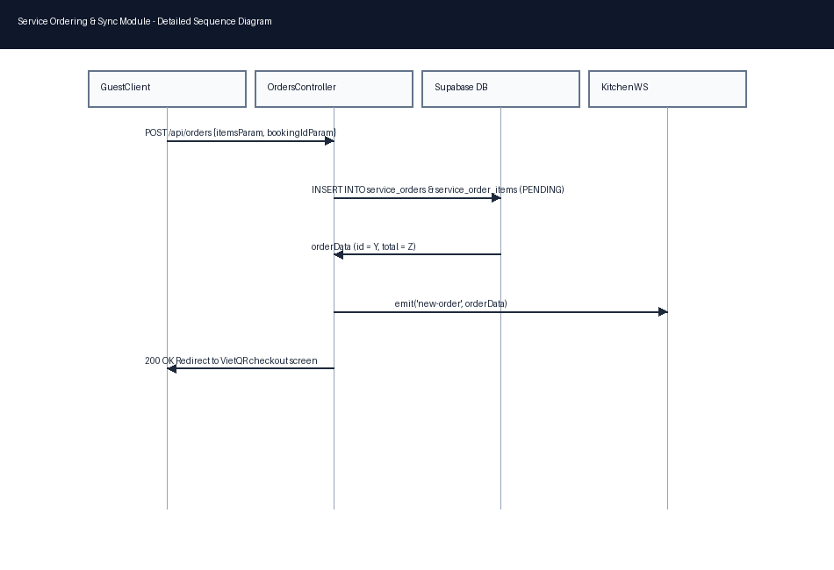

d. Database Queries

Insert Service Order Header
INSERT INTO service_orders (booking_id, status, total_amount, notes)
VALUES ($1, 'PENDING', $2, $3) RETURNING id;

Insert Service Order Item
INSERT INTO service_order_items (order_id, service_id, quantity, unit_price, subtotal)
VALUES ($1, $2, $3, $4, $5);

5. Payment & Audited Billing Module
Integrates the PayOS VietQR gateway for processing hotel bills, manages transaction logs, and automatically charges unpaid room incidents during check-out settlements.

a. Class Diagram
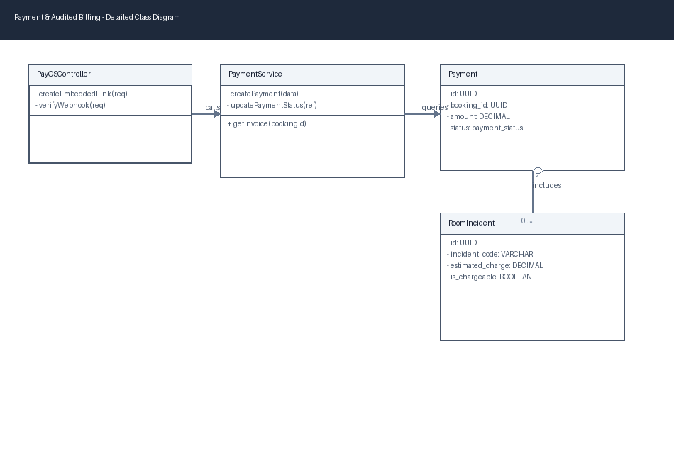

b. Class Specifications
Component / Class | Scope / Type | Responsibilities
PayOSController (Express Controller) | project/backend-payos/server.js | Coordinates payment link generations, Webhook listeners, and logs transaction signatures.
PaymentService (Service Class) | project/src/lib/db/bookings.ts | Generates final stay invoice rollups by querying rooms and incident fine charges.
Payment (Entity Class) | project/src/types/hotel.ts | Holds billing transaction fields (booking_id, amount, method, status, transaction_ref).
RoomIncident (Entity Class) | project/src/types/hotel.ts | Incident log fields (incident_code, severity, is_chargeable, approved_charge).

c. Sequence Diagram(s)
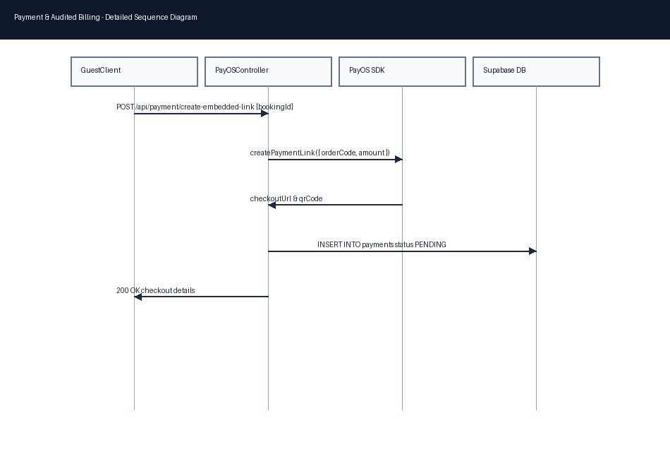

d. Database Queries

Add Payment Record
INSERT INTO payments (booking_id, amount, method, status, transaction_ref)
VALUES ($1, $2, 'TRANSFER', 'PENDING', $3);

Select Chargeable Incidents for Bill
SELECT * FROM room_incidents
WHERE booking_id = $1 AND is_chargeable = true AND status != 'RESOLVED';

6. Staff Management Module
Manages staff rosters (receptionists, housekeepers, kitchen staff), regulates role-based dashboard access, and records operational actions in audit logs.

a. Class Diagram
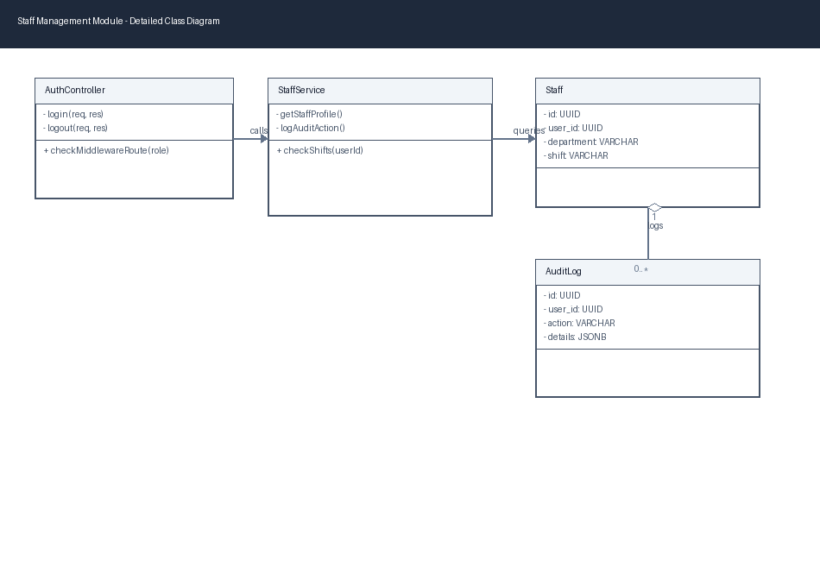

b. Class Specifications
Component / Class | Scope / Type | Responsibilities
AuthController (API Controller) | project/src/app/api/auth/login/route.ts | Validates username and passwords hashes, sets JWT cookies for requests.
StaffService (Service Class) | project/src/lib/db/users.ts | Retrieves staff department categories, shift lists, and logs system actions.
Staff (Entity Class) | project/src/types/hotel.ts | Maps internal employment credentials (user_id, department, shift).
AuditLog (Entity Class) | project/src/types/hotel.ts | Logs operational changes for tracking (user_id, action, details).

c. Sequence Diagram(s)
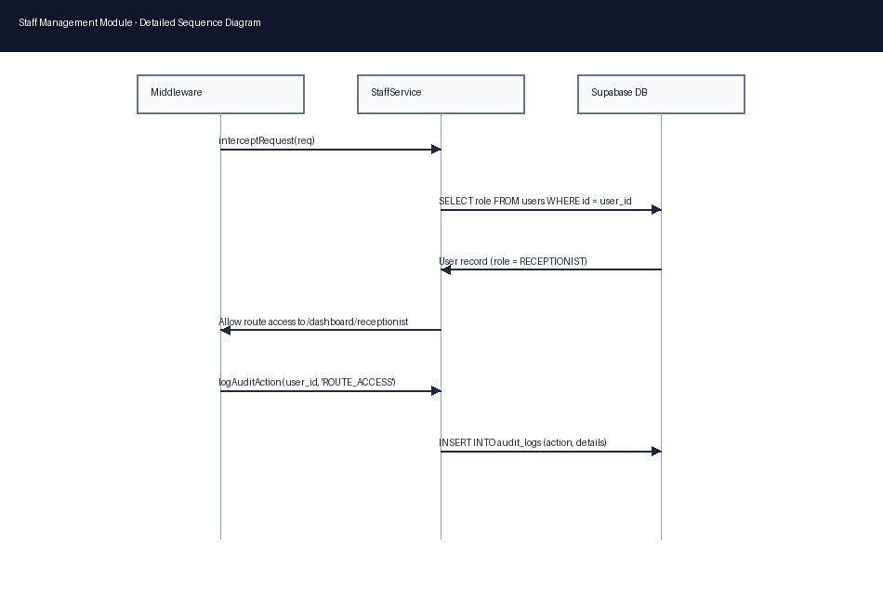

d. Database Queries

Record System Audit Log
INSERT INTO audit_logs (user_id, action, entity_type, entity_id, details)
VALUES ($1, $2, $3, $4, $5);

Query Staff Shift Roster
SELECT s.*, u.full_name, u.role FROM staffs s
JOIN users u ON s.user_id = u.id ORDER BY s.department ASC;

